
Hajee Mohammod Danesh Science & Technology University, Dinajpur-5200

Project Name:
Digital Attendance Taking System(DATS)

Course Code: CSE 152
Course Title: Structured Programming Language Sessional

Submitted by:
Name: Md Liakot Ali Liton
ID: 1802035

Objective of the project

General Objective:
Objective of the project is to digitalized our attendance taking system.

Specific Objective:
The main goal is to save our time and keep concentration of each student about the topic of the class. There is another goal is that no one can be able to show present in the class without attend in the class. This project also can save the all information of each student.

Inspirations of the Project
My inspirations about the project is our present attendance taking system. In the present attendance taking system I see that it take a lot of time to take attendance of student and it break our concentration about the topic of our class. There is also lot of chance to give proxy of another student who is not present in the class. This system is also take too much time to count the attendance marks of each student, which is another pathetic work for the teacher.
So, I’m try to overcome those problem using my project.

Description of the project
This project is for taking attendance digitally. It can store more than one class attendance record and process the record.

First we have to give all the information of a particular class, then we can take the attendance of the class students.

Advantages
The advantages of this project is:

- This project can save our time,
- It can calculate the total marks and attendance percentage correctly and fastly,
- We can see our attendance every time,
- It can save more than one class attendance file.
- It can reduces the proxy tendency.

Functionalities
The functionalities of this project is:
- It can store more than one student record file,
- It can access any file at any moment,
- It can delete or add any file every time,
- It can show the student’s attendance table at any moment,
- It can work in our previous created file.

Technical Description

Technical functionalities or options
At first:
Press-
- To create new file,
1(a). Give Department information,
1(b). Give Students information,
(Then you can access all option of 2)

- To open already created file,
2(a). Take attendance,
2(b). See students table,
2(c). Add new file,
2(d). Delete the file,

- To exit the file.

Technical Tools Used
Language: C
IDE : Codeblocks
Tools: Structure, file management, functions etc.

Data Storage:
All the data are storage at (.txt) file.

Output of the Project

Opening window:
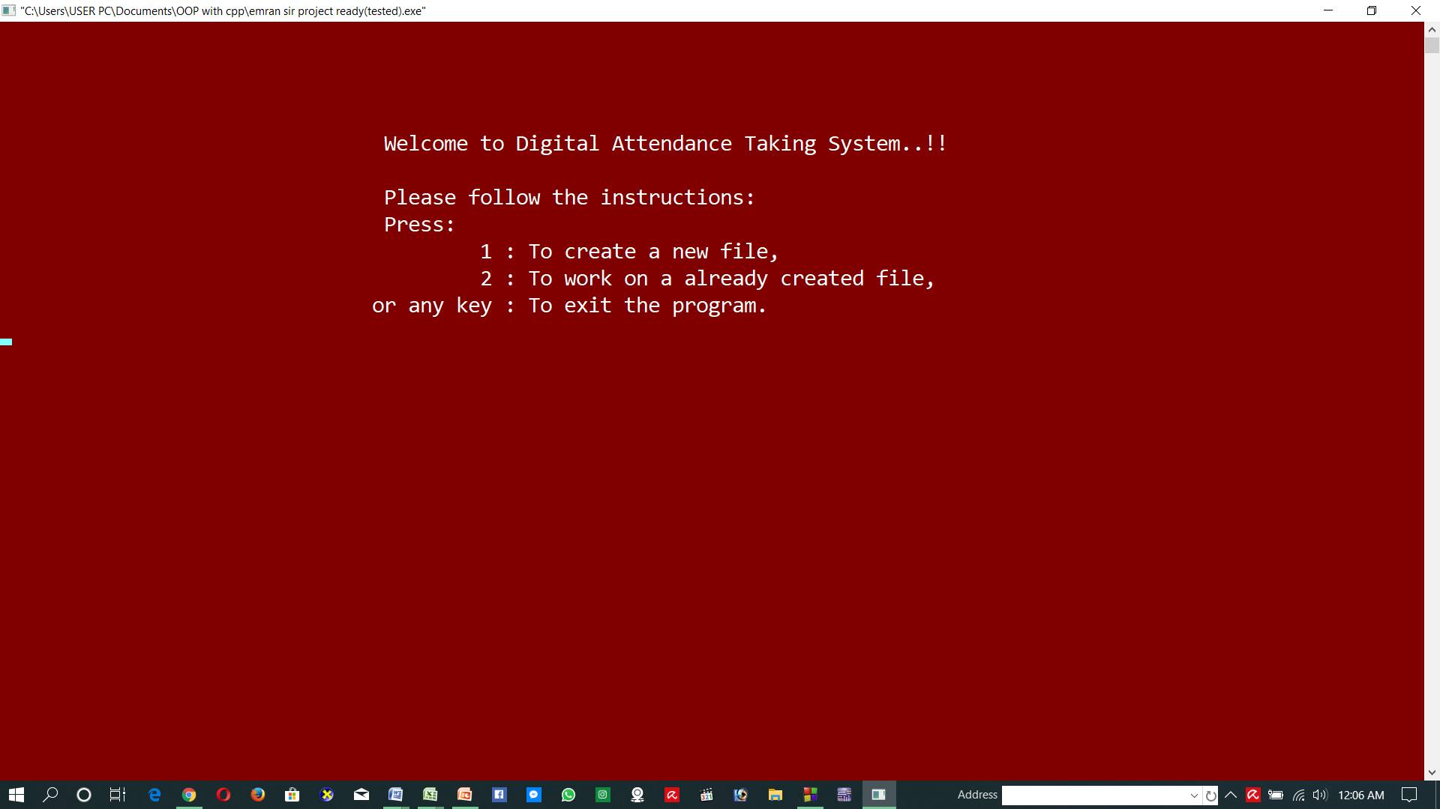

New file created
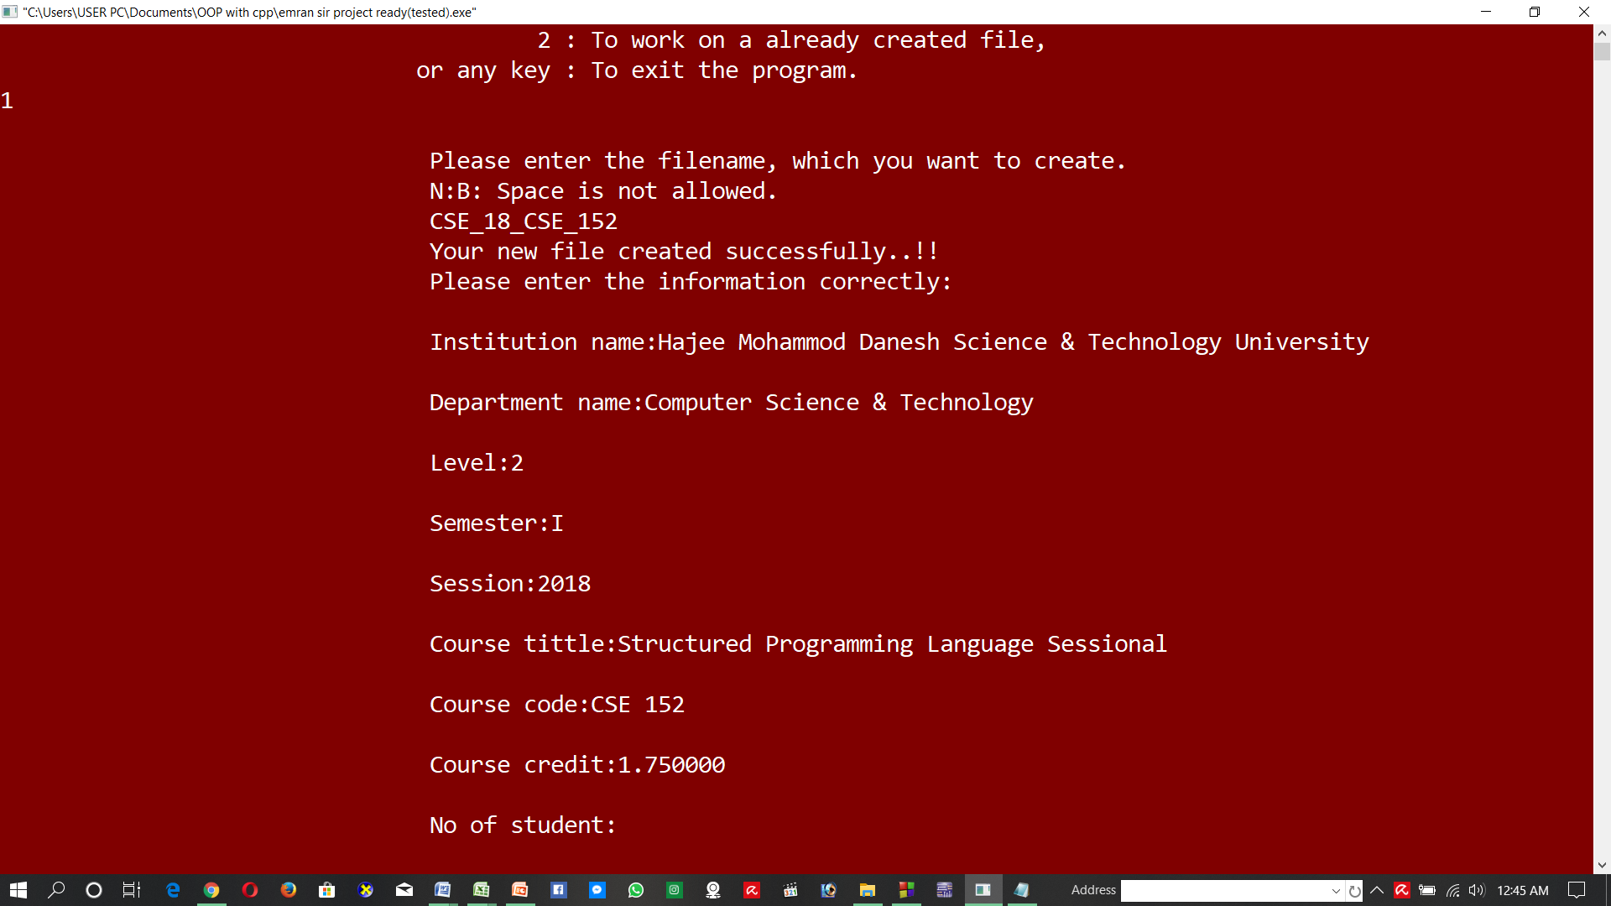

Taking attendance
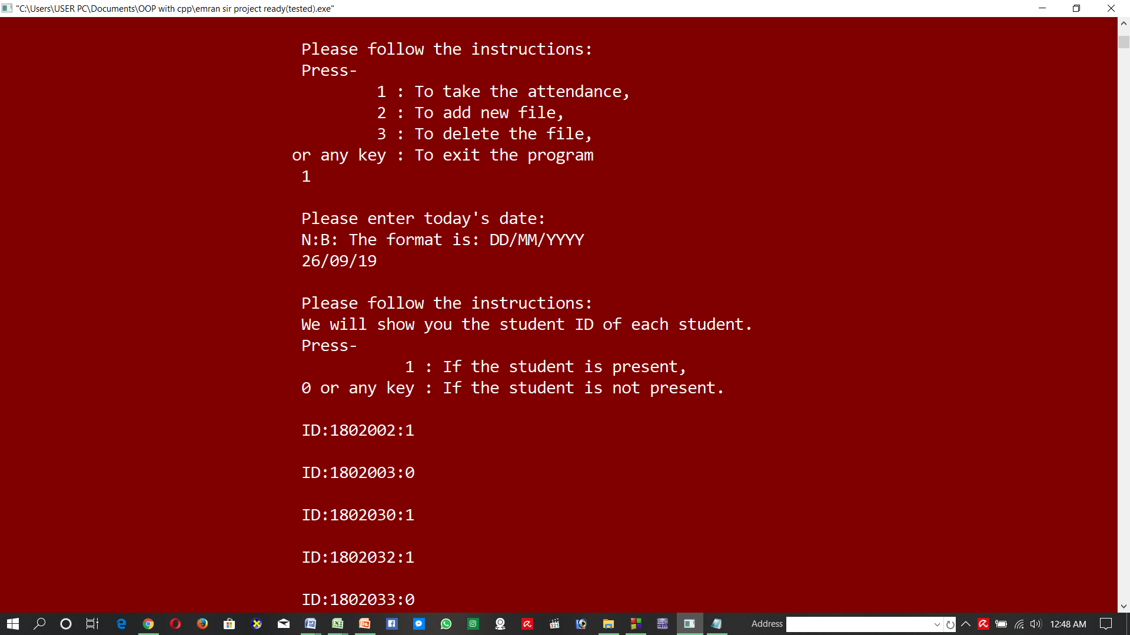

Students table
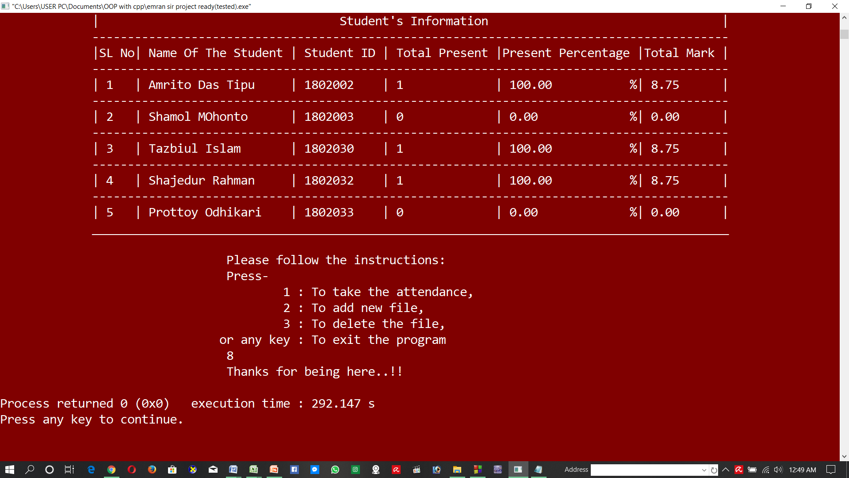

Limitations of the Project
This project can’t take attendance from more than one file. It can work on a file at a time.

Summary of the Project
At first using this project we have to create a file which contain department information and students information. Then the program show some option. Using the options you can take the attendance of the students, add new file or delete the file. After taking attendance you can see the students attendance table which contain all the summary of the department. It also calculate the total attendance percentage and total mark per student depend on their present in the class and total class days.
This project can save our time in the class and reduces our complexity to count the students attendance mark.

Thank you..!!!

